2021PECIT209

[Draw your reader in with an engaging abstract. It is typically a short summary of the document. When you’re ready to add your content, just click here and start typing.]

[Document title]

[Document subtitle]

TASK 1

NUMBER GAME

**PROGRAM:**

import java.util.Random;

import java.util.Scanner;

public class GuessingGame {

public static void main(String[] args) {

Scanner scanner = new Scanner(System.in);

Random random = new Random();

int maxAttempts = 5; // Modify this for desired attempt limit

int score = 0;

char playAgain;

do {

// Generate random number

int randomNumber = random.nextInt(100) + 1; // Range 1 to 100

// Game loop for each round

int attempts = 0;

boolean guessedCorrect = false;

while (attempts < maxAttempts && !guessedCorrect) {

System.out.println("Guess a number between 1 and 100 (Attempts: " + (attempts + 1) + ")");

int guess = scanner.nextInt();

if (guess == randomNumber) {

guessedCorrect = true;

score++;

System.out.println("Congratulations! You guessed the number in " + (attempts + 1) + " attempts.");

} else if (guess < randomNumber) {

System.out.println("Your guess is too low. Try again!");

} else {

System.out.println("Your guess is too high. Try again!");

}

attempts++;

}

if (!guessedCorrect) {

System.out.println("You ran out of attempts. The number was: " + randomNumber);

}

// Ask user to play again

System.out.println("Play again? (y/n)");

playAgain = scanner.next().charAt(0);

} while (playAgain == 'y' || playAgain == 'Y');

System.out.println("Thanks for playing! Your final score is: " + score);

scanner.close();

}

}]

\

**OUTPUT:**

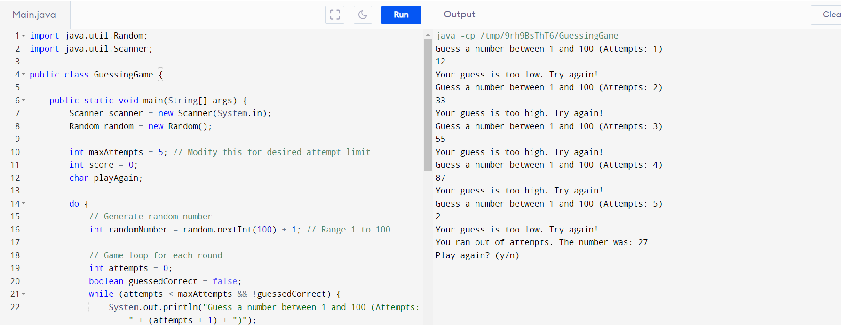

TASk 2

CURRENCY CONVERTER

**PROGRAM:**

import java.util.Scanner;

public class CurrencyConverter {

public static void main(String[] args) {

Scanner scanner = new Scanner(System.in);

// Exchange rates (for demonstration purposes)

double usdToEur = 0.85;

double usdToGbp = 0.72;

double usdToInr = 83.13;

// Display available currencies

System.out.println("Available currencies:");

System.out.println("1. EUR");

System.out.println("2. GBP");

System.out.println("3. INR");

// Take input for target currency

System.out.print("Enter target currency: ");

int targetCurrency = scanner.nextInt();

// Take input for amount

System.out.print("Enter amount to convert: ");

double amount = scanner.nextDouble();

// Perform currency conversion

double convertedAmount = 0.0;

if (targetCurrency==1){

convertedAmount = amount * usdToEur;

} else if (targetCurrency==2) {

convertedAmount = amount * usdToGbp;

} else if (targetCurrency==3) {

convertedAmount = amount * usdToInr;

}

else {

System.out.println("Invalid target currency.");

return;

}

// Display result

System.out.println("Converted amount: " + convertedAmount + " " + targetCurrency);

// scanner.close();

}

}

**OUTPUT:**

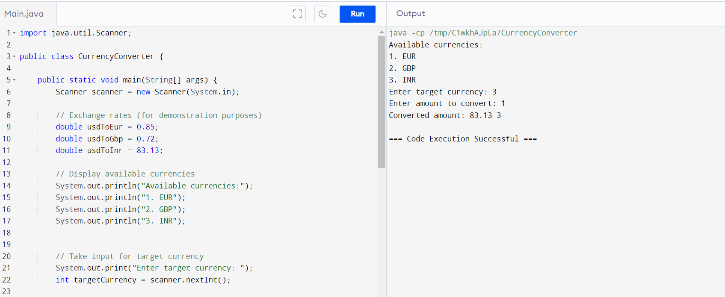

**TASK 3**

**STUDENT GRADE CALCULATOR:**

**PROGRAM:**

import java.util.Scanner;  
  
public class studentmark {  
    public static void main(String[] args) {  
        Scanner scanner = new Scanner(System.in);  
  
        // Take input for the number of subjects  
        System.out.print("Enter the number of subjects: ");  
        int numSubjects = scanner.nextInt();  
  
        // Initialize total marks to 0  
        int totalMarks = 0;  
  
        // Take input for marks in each subject and calculate total marks  
        for (int i = 1; i <= numSubjects; i++) {  
            System.out.print("Enter marks for subject ");  
            int marks = scanner.nextInt();  
            totalMarks += marks;  
        }  
  
        // Calculate average percentage  
        int average = (int) totalMarks / (numSubjects * 100) * 100;  
  
        // Assign grade based on average percentage  
        String grade;  
        if (average >= 90) {  
            grade = "A";  
        } else if (average >= 80) {  
            grade = "B";  
        } else if (average >= 70) {  
            grade = "C";  
        } else if (average >= 60) {  
            grade = "D";  
        } else {  
            grade = "F";  
        }  
  
        // Display results  
        System.out.println("\nResults:");  
        System.out.println("Total Marks: " + totalMarks + "/" + (numSubjects * 100));  
        System.out.println("Average : "+ average);  
        System.out.println("Grade: " + grade);  
  
        scanner.close();  
    }  
}

**OUTPUT:**

